 Exception Rules

Investigation Exercise

- In Studio, look at the sample Activity Escalation Rules. Why can the rules assume that the activity is overdue?

- Look at the claim exception rule shown below. How is this rule preventing repeated creation of the create_recovery_email_bill1 activity?

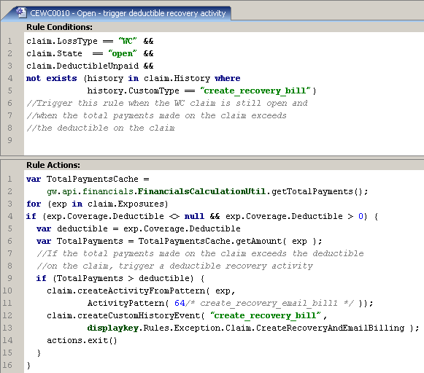

3. What would be another way to prevent the repeated creation of the create_recovery_email_bill1 activity?

Configuration Exercise

Configure ClaimCenter to meet the following customer requirements from Acme Insurance.

Requirement 1: Flag any open auto over 30 days old that no value set for fault rating.

Acme Insurance wants representatives to be able to log an auto claim without determining who is at fault. However, if this information has not been entered within 30 days, the claim should be flagged.

- Create an exception rule which flags all claims where:
- The loss type is “auto”.
- The reported date is more than 30 days ago.
- There is no value for Fault Rating on the Loss Details screen.
The flag description should be “No value specified for Fault Rating.”

Test Cases: Requirement 1

When you have completed your configuration, test your solution.

- Test several claims that are not yet flagged for any reason.
  - Search for auto claim 235-53-373906. Verify that it is open and more than 30 days old. Change one or more fields on the Loss Details screen to ensure that the exception rules fire for the claim.
  - Search for auto claim 235-53-365871. Verify that it is open and more than 30 days old. Change Loss Cause to Collision with fixed object and change Fault Rating to “Insured at fault”.
  - Search for property claim 426-24-366072. Verify that it is open, more than 30 days old, and does not have a fault rating. On Loss Details, change one or more fields to ensure that the exception rules run for this claim.
  - Use maintenance_tools to run the claim exception rules for changed claims.
  - Examine the claims and determine whether they are flagged appropriately.

Claim | Characteristics | Flagged?
235-53-373906 | Auto, open, more than 30 days old, no fault rating
235-53-365871 | Auto, open, more than 30 days old, has fault rating
426-24-366072 | Property, open, more than 30 days old, no fault rating

Requirement 2: Create an activity to get the police report

Acme would like to add an activity to get the police report for any auto claim more than 30 days old and does not have a value for Fault Rating. The code for this activity pattern is “police_report”. You need to check the claim to see if an open “police_report” activity does not yet exist. If it doesn’t exist, then you want to create a “police_report” activity. There should be only one open “police_report” activity to investigate and record this information.

- Modify your existing rule to meet this requirement. If desired, you can implement this requirement in two phases, first creating an activity every time the rule executes and later adding the code to prevent the creation of duplicate open activities.

Test Cases: Requirement 2

When you have completed your configuration, test your solution.

- Search for auto claim 345-53-343195. Verify that it is open, more than 30 days old, and does not have a fault rating. On Loss Details, change one or more fields to ensure that the exception rules run for this claim.
- Use maintenance tools to run the claim exception rules and confirm the activity is created.
- Modify claim 345-53-343195 again, run the claim exception rules, and verify that there is still only one activity for obtaining the police report.
- Close the activity and verify that the exception rules will open a new activity for obtaining the police report.

